Filtering dates and times in SQL

**Introduction**

As a security analyst I had to filter through dates to see what devices needed the latest updates, to increase security. Also, I had to check login attempt counts, to determine whether there’s been malicious activity in the system.

**Objectives**

1. Filter for login attempts made after a certain date
2. Filter for login attempts made in a certain date range
3. Filter for login attempts made at a certain time
4. Filter for login attempts by ID

**Filter for login attempts made after a certain date**

In this task I had to filter login attempts before 7am in response to a recent security event.

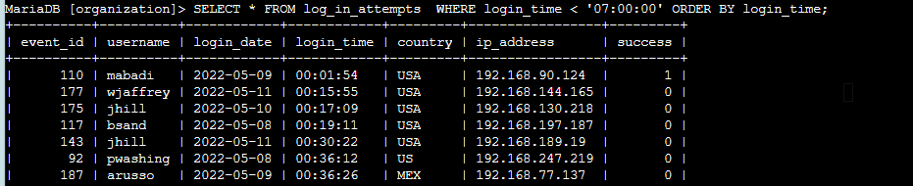

**Filter for login attempts made in a certain date range**

Expanding on my query above I decided to narrow my search down to logs between 6am and 7am.

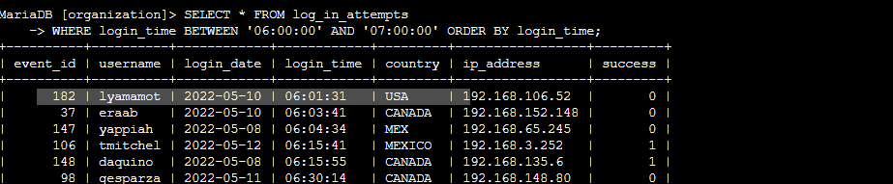

**Filter for login attempts made at a certain time**

In this query I looked at logs made at a specific time.

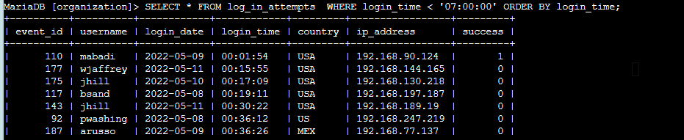

**Filter for login attempts by ID**

Lastly, I decided to check the event IDs to gain a clearer understanding on users making these login attempts before normal working hours.

